**Assignment 6.2 – Aggregate Queries**

Patrick Cuauro

Bellevue University

WEB 335-307O Introduction to NoSQL

Professor Krasso

June 27, 2023

## Query to show a list of documents in the houses collection.

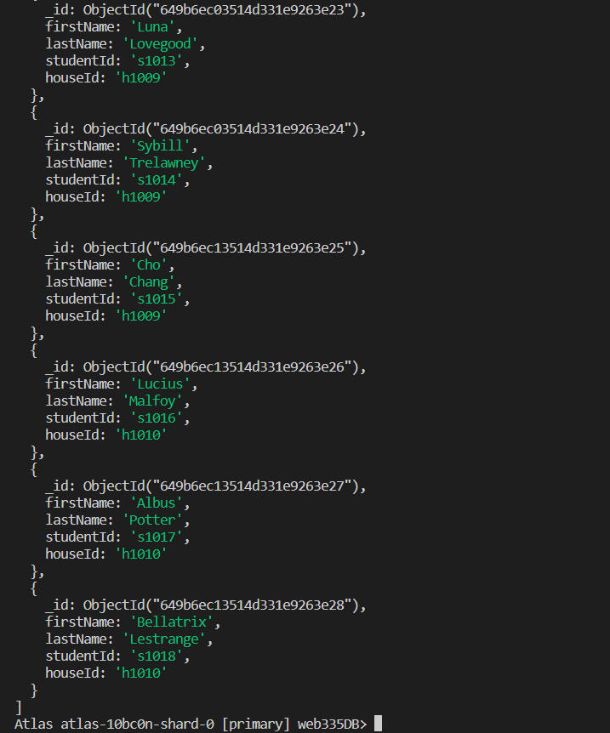

## Query to show a list of documents in the student’s collection.



## Query to add a document to the student’s collection.

Note: I have should used a predetermined house id, I don’t belong to no houses now!

## Query to prove the document was added to the user’s collection.

Query to delete the document previously created.

## Query to prove the document was removed from the user’s collection.

## Query to show a list of students by house using $lookup

## Query to show a list of students for house Gryffindor using $lookup and $match.

## Query to show a list of students for the Eagle mascot using $lookup and $match.